COS711 Assignment 2: Team Plan and Implementation Guide
Oct 30, 2026 · @alisha

Overview
Submit one zip to ClickUP by Sunday 1 November 2026, 23:30, containing your code, submission.csv, a video of at most 10 minutes and 50 MB, and the PowerPoint slides. Only the last upload is marked, so upload a complete version early and replace it later.
The task is to segment solar filaments in 2048 x 2048 grayscale H-Alpha (GONG) images from the MAGFiLO dataset on Kaggle's Solar Filament Segmentation Challenge 2026. Kaggle ranks submissions by Panoptic Quality (PQ), an instance-level metric, so merging or fragmenting filaments costs marks even when most pixels are right.
Marked section | Marks
Format (presentation requirements) | 5
Data preparation | 10
Experimental setup and methodology | 20
Segmentation results | 30
Segmentation enhancement (instance separation, post-processing, compression) | 30
Conclusions | 5
Bonus: top 100 on the Kaggle leaderboard (screenshot) | up to +5 (total capped at 100)
The video is the primary deliverable. Code and the submission file are evidence of authenticity, but leaving either out halves your total mark.
Strategy in one paragraph: get a baseline U-Net trained, scored locally and submitted to Kaggle today. Then spend the remaining time on a small number of well-motivated improvements (thin-structure loss, instance separation, post-processing, high-resolution inference), measure each one against the baseline, compress the best model, and record the video with a day to spare.

Team roles
Split the work three ways so that each person owns one section of the video and one block of code. Swap names in as you decide; every member must appear on screen and state their responsibility.
Role | Owns | Code files | Video section
Person A: data and evaluation | EDA, cleaning, observation-grouped split, augmentation, local metrics (PQ, SQ, RQ, Dice, IoU, one-to-many, many-to-one) | data.py, metrics.py, eda.ipynb | Dataset preparation; part of Results
Person B: modelling | Architectures, losses, training loop, hyperparameter tuning, repeated seeds, experiment log | models.py, losses.py, train.py | Experimental setup and methodology; part of Results
Person C: instances, compression, delivery | Post-processing, instance separation, pruning, distillation, timing, submission.csv, slide assembly, video merge and zip | postprocess.py, compress.py, predict.py | Segmentation enhancement; Conclusions
Shared by all three
- Everyone records their own talking-head segment (head and shoulders, upper right of the slides).
- Everyone adds the slides for their own section to one shared PowerPoint built from the ClickUP template.
- Everyone writes their findings into the experiment log as they get them, not at the end.
- One person (suggest C) is the single owner of the final zip, so there is only one version of the truth.
Working agreements
- One shared Git repo or Drive folder; commit small and often.
- One shared Kaggle or Colab GPU plan: agree who is training when, because free GPU quotas are limited.
- Fix random seeds and save every config with its results, so any number on a slide can be reproduced.

Rules and pitfalls
Breaking the first two rules is academic misconduct; the others cost marks.
- No external test labels. MAGFiLO is published elsewhere with annotations for the test images. Never download or use that version. Use only the data on the Kaggle Data page.
- No extra ground-truth metadata for training. The Kaggle rules say models may not use other ground-truth metadata. Train on the segmentation masks only. If you want a skeleton or centreline target, compute it from the mask with skimage.morphology.skeletonize instead of reading the spine field. Bounding boxes and class labels (Left, Right, Unidentifiable, Ambiguous) are not needed for PQ.
- Inference uses only the test images. Do not feed timestamp or instrument codes from the file name into the model. Using them to build the train/validation split is fine.
- Group the split by observation. Annotation sets such as 010101-20260901165702Bh and 010102-20260901165702Bh share one image. All sets for one observation must stay on the same side of the split, and nearby times or the same instrument are not independent, so hold out contiguous time blocks.
- Do not tune on the leaderboard. You get limited Kaggle submissions. Implement PQ locally and tune on your validation set.
- Accept and follow the Kaggle competition rules before submitting.
- Python only, as notebooks or scripts. Any deep learning framework is allowed.
- Missing code or submission.csv halves your total mark. Check the zip before uploading.
- Video limits: at most 10 minutes and 50 MB, with all members visible head and shoulders in the upper right corner.
- Report model size, training time and end-to-end inference time. Compression experiments are expected.

Timeline
There are about 57 hours between now (Friday 30 October, afternoon) and the deadline (Sunday 1 November, 23:30). The schedule has three checkpoints: a baseline scored on Kaggle by Friday 23:00, a configuration freeze on Saturday 18:00, and a first complete zip uploaded on Sunday 19:00. All times are SAST.
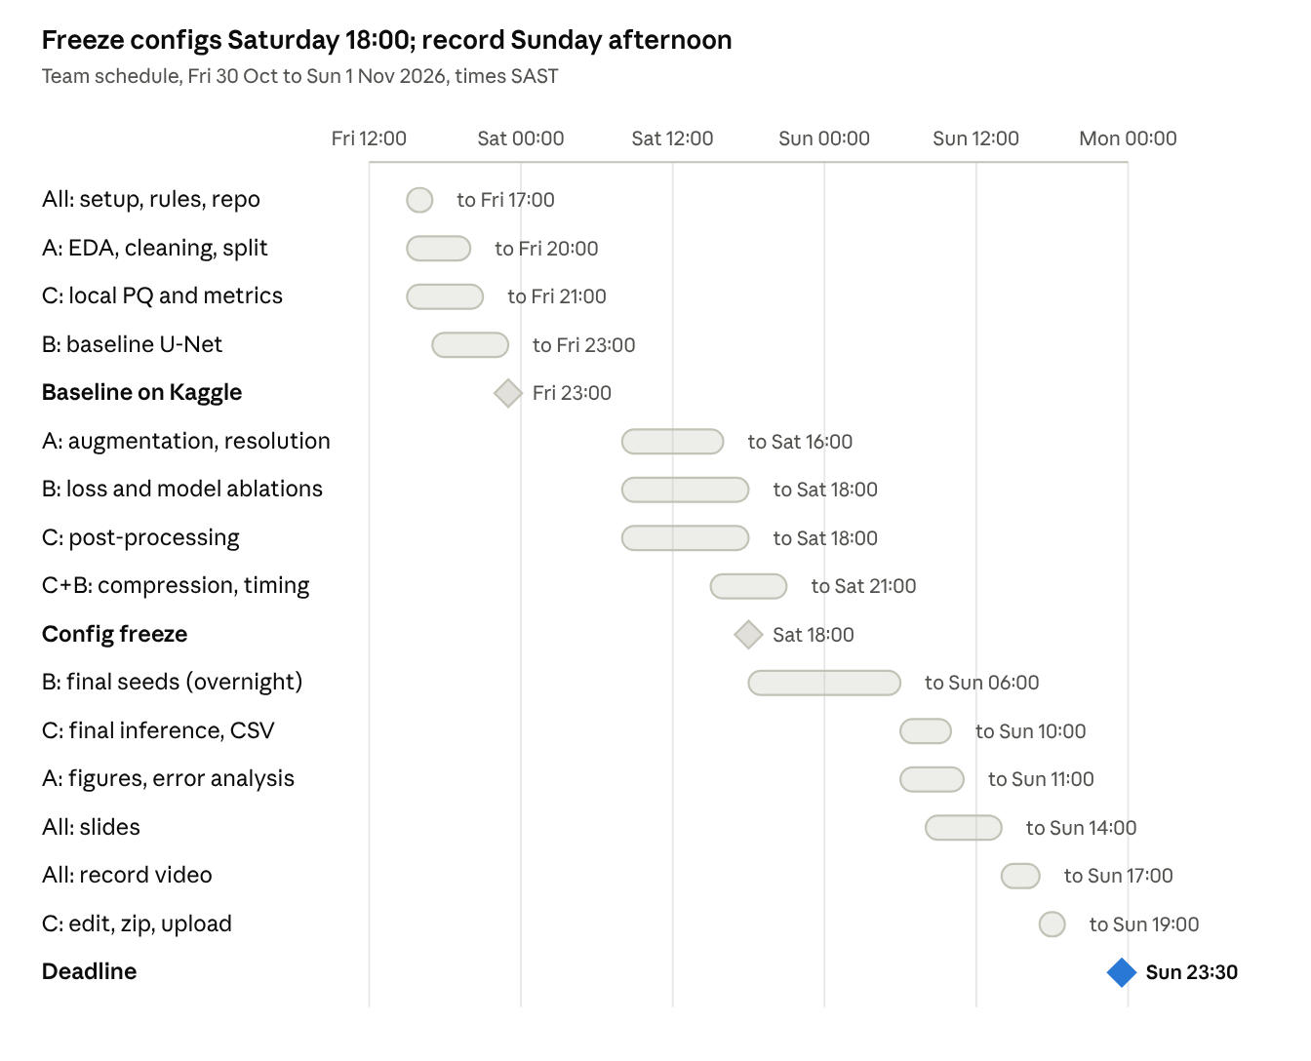
team schedule · 3 days, 3 people, 3 checkpoints
People work in parallel on Friday and Saturday; Sunday is for final runs, slides and recording. Compression runs on the best configuration so far, and its numbers are re-checked on the frozen model on Sunday.
Slip rules
- If the baseline is not on Kaggle by Friday 23:00, drop everything except getting a valid submission.csv; improvements mean nothing without one.
- If an idea has no measured gain by Saturday 18:00, leave it out of the final pipeline but keep the result for the slides; a negative result is still a finding.
- Never start a new experiment after the freeze. Spend that time on seeds, compression numbers, figures and slides.
- Upload the zip on Sunday by 19:00 even if it is imperfect; you can replace it before 23:30.

Step-by-step guide
Work through these seven steps in order. Steps 1 to 3 are the foundation, step 4 gives you a reference score, and steps 5 and 6 are where most of the marks are won.

Step 1: Get the data and explore it (Person A, Friday afternoon)
- Join the competition on Kaggle, accept the rules, and download the data. You get train/train_images/, MAGFiLO_1.0_Annotations_kaggle2026_train.json and test/test_images/.
- Install the tools: pycocotools, opencv-python, scikit-image, albumentations, segmentation_models_pytorch, torch.
- Parse each file name (YYYYMMDDHHMMSSII) into capture time and a two-letter instrument code.
- Answer these questions. Each answer becomes a line on the Dataset slide:
  - How many image entries are there, and how many unique observations (images sharing the same file_name)?
  - How many annotators label each observation? Do all annotators label all observations?
  - How many filaments per image? Are there images with no annotation?
  - What fraction of pixels is filament? Expect it to be very small.
  - Which instruments and date ranges appear in train, and (from the file names only) in test?
  - Do any instances overlap within one annotation set, or have tiny or degenerate polygons?
  - How closely do two annotators agree on the same image? Score one annotator against another with your PQ code. This is a rough ceiling for any model.
- Look at 20 to 30 images by eye, including some with bad noise, faint filaments and disagreeing annotators. These become your "noisy samples" examples.
Starter EDA snippet:
import json, collections
from pycocotools import mask as mu
d = json.load(open("train/MAGFiLO_1.0_Annotations_kaggle2026_train.json"))
obs = collections.defaultdict(list) # observation -> annotation-set image ids
for im in d["images"]:
obs[im["file_name"].split(".")[0]].append(im["id"])
print(len(d["images"]), "image entries,", len(obs), "observations")
print(collections.Counter(s[14:16] for s in obs).most_common()) # instruments
print(collections.Counter(s[:4] for s in obs).most_common()) # years
def ann_mask(a, h=2048, w=2048):
return mu.decode(mu.merge(mu.frPyObjects(a["segmentation"], h, w)))

Step 2: Build instance masks and the split (Person A, Friday evening)
- For every annotation, decode the polygon to a binary mask with the snippet above. Build an integer instance map per annotation set (0 = background, 1..N = filaments). Cache these to disk so training does not decode polygons every step.
- Split by observation, in time blocks. All annotation sets of one observation must be on the same side. Sort observations by time and hold out whole contiguous blocks (for example whole weeks or months), because images close in time and from the same instrument are not independent. Aim for roughly 15 to 20 percent for validation, then check the instrument mix against the test file names.
- Decide how to treat multiple annotators. Start with Kaggle's suggestion (treat each annotation set as its own training sample). Later, ablate against a consensus target (for example majority vote). Read the Kaggle Evaluation page to see how the ground truth is built for scoring, since that tells you which choice matches the test.
- Write the choices down with the reason for each. The split justification deserves its own slide.

Step 3: Write the local metrics (Person C, Friday afternoon and evening)
Implement the Panoptic Quality definition from Kirillov et al. A predicted filament matches a ground-truth filament when their IoU is above 0.5; with that threshold each ground-truth filament has at most one match.
PQ = \frac{\sum_{(p,g)\in TP} \mathrm{IoU}(p,g)}{|TP| + \tfrac{1}{2}|FP| + \tfrac{1}{2}|FN|} = \underbrace{\frac{\sum \mathrm{IoU}}{|TP|}}_{SQ} \times \underbrace{\frac{|TP|}{|TP| + \tfrac{1}{2}|FP| + \tfrac{1}{2}|FN|}}_{RQ}
Also compute the other quantities the Kaggle judges look at, so you can plot them yourself:
- Per-filament Dice and IoU (report distributions as histograms, not just means).
- One-to-many: ground-truth filaments split across two or more predictions (fragmentation).
- Many-to-one: predictions that cover two or more ground-truth filaments (merging).
- Your own overlap threshold for the last two is an assumption until you confirm Kaggle's definition on the Evaluation page. Say so on the slide.
Unit-test it on tiny hand-made masks: a perfect prediction scores 1, an empty prediction scores 0, two merged filaments and one split filament each score below 1 and show up in the right counter. Do this before anyone trusts a number.

Step 4: Train a baseline and submit it (Person B, Friday evening)
The baseline is the reference every later improvement is measured against, and it proves your submission format works.
- Model: a U-Net from segmentation_models_pytorch with a pretrained ResNet34 encoder and in_channels=1, because the images are grayscale. Do not duplicate the channel to fake RGB.
- Loss: binary cross-entropy plus Dice. Optimiser: AdamW with a cosine schedule and mixed precision.
- Input: random 512 x 512 crops at full resolution, with a share of crops forced to contain filament. 2048 divides by 32, so the network can run on whole images at inference, or in overlapping tiles if memory is tight.
- Convert the probability map to a binary mask at 0.5, then label connected components to get instances.
- Convert instances to the format on the Kaggle Data and Evaluation pages (check the sample submission file; it is likely run-length encoded masks per instance, but confirm). Write submission.csv and submit it to confirm Kaggle accepts the format.
- Score the same model locally with Step 3 and record both numbers. If the local and Kaggle scores differ greatly, fix the metric or the split before going further.
import segmentation_models_pytorch as smp
model = smp.Unet("resnet34", encoder_weights="imagenet", in_channels=1, classes=1)
dice = smp.losses.DiceLoss("binary")
bce = torch.nn.BCEWithLogitsLoss()
loss_fn = lambda logits, y: bce(logits, y) + dice(logits, y)

Step 5: Go beyond the baseline (all three, Saturday)
These ideas are where the 30 enhancement marks and much of the 30 results marks come from. Change one thing at a time, compare against the baseline on the same validation split, and write the result into the experiment log even if it is negative.
Idea | Why it should help | Watch these numbers | Owner
Full-resolution crops with tiled inference versus downsampling to 1024 | Barbs and fine structures are thin and can vanish when downsampled | PQ, Dice on thin parts, inference time | A and B
Preprocessing: mask outside the solar disc, CLAHE or local normalisation | Limb darkening and ground-based noise affect contrast | PQ, number of false positives | A
Augmentation: flips, rotations, scale, brightness and contrast, noise, blur | Small dataset, varying observing conditions | PQ, validation gap | A
Loss: add Tversky, focal, boundary, or a skeleton-based loss such as clDice (skeleton computed from the mask) | Class imbalance and thin structures; continuity of filaments | PQ, one-to-many count | B
Architecture: UNet++, attention gates, or a transformer encoder such as SegFormer | Denser skips or global context may keep filaments connected | PQ, parameters, speed | B
Instance separation: add a distance-transform or boundary output and run watershed | Touching filaments merge under plain connected components | Many-to-one count, PQ | C with B
Post-processing: tune threshold, remove small components, fill holes, bridge small gaps with morphological closing | Removes "islands" and reconnects fragments | One-to-many count, false positives, PQ | C
Test-time augmentation (flip averaging) and EMA weights | Smoother, more stable predictions | PQ, inference time | C and B
Consensus target versus separate annotation sets | Annotator disagreement acts as label noise | PQ on validation | A
Tune the threshold and post-processing parameters on validation predictions, never on the leaderboard.

Step 6: Compress the model (Person C with Person B, Saturday afternoon)
The assignment and the Kaggle description both ask for efficiency, and recommend pruning, distillation or other compression. Start on the best configuration you have by early Saturday afternoon, then re-measure the frozen model on Sunday.
Variant | How to do it | What to record
Full model, FP32 | Your best model as trained | Parameters, file size (MB), PQ, ms per image
FP16 or mixed-precision inference | model.half() or autocast; check PQ did not drop | Same four numbers
ONNX export | Export and run with ONNX Runtime | Same four numbers, plus whether outputs match
Structured pruning | Remove low-importance channels (for example with the torch-pruning library), then fine-tune | Same four numbers, plus fraction pruned
Knowledge distillation | Train a smaller student (ResNet18 or a MobileNet encoder) on the large model's soft outputs plus the labels | Same four numbers, plus training time
INT8 quantisation (optional) | Post-training or quantisation-aware, if time allows | Same four numbers
Measure end-to-end time per image on the same hardware, at batch size 1: read the file, preprocess, run the model, post-process, and encode the result. Report model size and the time to train as well. A table of all variants with PQ against milliseconds per image is a strong results slide.

Step 7: Final runs and submission (Saturday evening to Sunday morning)
- Freeze the pipeline at Saturday 18:00: architecture, loss, resolution, augmentation, post-processing and compression choice.
- Train the frozen configuration with at least three different random seeds. Report local PQ as mean and standard deviation, and do the same for Dice and IoU if time allows.
- Choose the submission model by validation PQ. Run it on the test images through predict.py and write submission.csv.
- Submit to Kaggle. Keep the exact file you uploaded; it goes in the zip.
- Record the Kaggle score for the best model, and for one or two other variants if submissions allow.
- If you land in the top 100, take a screenshot of the leaderboard for the bonus marks.

Tech stack and repo layout
Use PyTorch with segmentation_models_pytorch: it gives you pretrained encoders and many decoder types behind one API, so each architecture change is a one-line ablation.
Need | Tool
Deep learning | PyTorch, segmentation_models_pytorch
Annotations and RLE | pycocotools
Augmentation | albumentations
Skeletons and morphology | scikit-image, opencv-python
Instance separation | scipy.ndimage, skimage.segmentation.watershed
Compression | PyTorch FP16, ONNX and ONNX Runtime, torch-pruning
Compute | Kaggle notebooks, Google Colab, or Google Cloud free resources
Experiment log | A shared spreadsheet or CSV plus saved config files
The Kaggle rubric also scores code quality (modularity and documentation). A layout like this is easy to explain and easy to mark:
README.md how to run each step, in order
eda.ipynb exploration and the figures for the Dataset slide
data.py COCO to instance masks, split, dataset, augmentation
metrics.py PQ, SQ, RQ, Dice, IoU, one-to-many, many-to-one
models.py architecture variants
losses.py loss functions
train.py config-driven training and seeds
postprocess.py threshold, components, watershed, gap bridging
compress.py FP16, pruning, distillation, timing
predict.py test images to submission.csv
configs/ one file per experiment
Practical tips
- Free GPU sessions end without warning. Save checkpoints and logs to persistent storage every epoch and make train.py resumable.
- Cache decoded masks and, if disk allows, preprocessed images. Polygon decoding on every step wastes GPU time.
- Read every parameter from a config file and save the config next to each result. This is what makes ablations reproducible.
- Keep the validation split fixed for all experiments, so numbers are comparable.
- Time each stage of inference separately from the start, so the end-to-end number is easy to report.

Experiment log and results plan
Keep one row per experiment, filled in by whoever ran it, as soon as it finishes. Every claim on the Results and Enhancement slides should point back to a row here. Fill in the real numbers as you go.
ID | Change from previous | Seeds | Val PQ | SQ | RQ | One-to-many | Many-to-one | ms per image | Kaggle PQ
E0 | Baseline U-Net, ResNet34, BCE + Dice
E1 | Resolution: crops versus downsample
E2 | Preprocessing and augmentation
E3 | Loss for thin structures
E4 | Architecture change
E5 | Instance separation
E6 | Post-processing
E7 | Compression (add a row per variant)
Figures to produce for the Results slides
- Table of all variants with the mean and standard deviation of PQ over repeated runs.
- Histograms of per-filament Dice and IoU for the baseline and the final model.
- Counts of one-to-many and many-to-one relations before and after post-processing. This is the clearest evidence that instance separation worked.
- PQ against milliseconds per image for the compression variants.
- Prediction overlays on test images: three best and three worst, each with one sentence on why.
- A short error taxonomy with examples: merged filaments, fragmented filaments, missed faint filaments, false "islands" in noise, lost barbs.
Reporting rules
- Report mean and standard deviation over at least three runs where feasible, not the best single run.
- Report the local score and the Kaggle score side by side, and comment if they differ.
- State the size of the final model, the time to train it, and the end-to-end inference time per image.

Video and slides plan
The video is the primary deliverable, so plan it as carefully as the model. It must be at most 10 minutes and 50 MB, with each team member visible (head and shoulders) in the upper right corner, and each person's responsibility stated clearly. Start from the PowerPoint template on ClickUP.
Slides | Content | Speaker | Time
Title and roles | Team, who did what | All three, one sentence each | 0:30
Dataset preparation | Findings from EDA, noisy samples, class imbalance, preprocessing, augmentation, the split and why | A | 1:30
Experimental setup and methodology | Tools, how the problem is framed, models, losses, training, tuning, how you evaluated | B | 2:00
Results | Local and Kaggle PQ with mean and standard deviation, comparison of approaches, Dice and IoU histograms, error types, best and worst predictions | A and B | 2:30
Segmentation enhancement | Instance separation, post-processing, thin-structure handling, compression, and how much each idea helped | C | 2:30
Conclusions | Take-aways, biggest roadblocks, what you would do differently | C, then all | 0:30
Bibliography | Resources used (not spoken) | None | 0:00
The total is 9:30, which leaves 30 seconds of slack. A mark-earning enhancement slide shows a number: for example, "post-processing cut many-to-one merges from X to Y and raised PQ from A to B".
Recording
- Record the slides with the camera on, using any screen recorder that can place your webcam in the upper right (OBS, Zoom or Teams recording). If you record separately, merge so that all three faces appear at some point.
- Rehearse once with a timer before recording. Cut anything that pushes past 10 minutes.
- Use large figures and few words per slide. Put best and worst prediction overlays full width.
- Leave at least two hours for editing and for fixing a bad take.
Meeting the 50 MB limit. At 10 minutes, 50 MB allows roughly 650 kbit/s in total. This command targets about 560 kbit/s including audio; check the size of the output and lower the video bitrate if it is over:
ffmpeg -i raw.mp4 -vf scale=1280:-2 -c:v libx264 -b:v 500k -c:a aac -b:a 64k video.mp4
Bibliography ideas: the MAGFiLO paper (Ahmadzadeh et al., Scientific Data, 2024), the Panoptic Segmentation paper (Kirillov et al., CVPR 2019), segmentation_models_pytorch, plus the papers behind any loss, architecture or compression method you use.

Final submission checklist
Go through this on Sunday afternoon, with all three of you, before the first upload at 19:00. Missing code or submission.csv halves the total mark.
Zip contents
- ☐ All code (notebooks or scripts), with a README that says how to run it
- ☐ submission.csv, the exact file you uploaded to Kaggle
- ☐ The video, at most 10 minutes and 50 MB
- ☐ The PowerPoint slides used in the video
- ☐ Optional: the leaderboard screenshot, if you are in the top 100
Checks
- ☐ The video plays on another computer, is within the time and size limits, and shows all three members
- ☐ Each member's responsibility is stated on screen or aloud
- ☐ Every section in the rubric below is covered
- ☐ Model size, training time and end-to-end inference time are reported
- ☐ No external labels for the test images were used anywhere in the code
- ☐ Code runs from the README steps and has docstrings
- ☐ The zip opens and has no stray large files (checkpoints, raw data)
- ☐ Uploaded to the ClickUP assignment slot (only the last upload is marked)
What each marked section needs on the slides
Section (marks) | Must show
Format (5) | Within 10 minutes and 50 MB, all members visible, roles stated, template followed
Data preparation (10) | EDA findings, noisy samples, imbalance, preprocessing, augmentation with evidence, observation-grouped split
Setup and methodology (20) | Problem framing, model, loss and training choices with reasons, tuning, local PQ implementation
Results (30) | PQ local and Kaggle, mean and standard deviation, comparisons, error types, best and worst predictions
Enhancement (30) | Instance separation, post-processing, thin-structure handling, compression, and each idea's measured gain
Conclusions (5) | Take-aways, roadblocks, what you would change

Open questions and risks
Four things are not settled by the pages you have shared so far, so check them on Kaggle in the first hour.
- ☐ Submission format: read the sample submission and the Data page. Confirm what a valid row looks like and how instances are encoded.
- ☐ Evaluation details: how are multiple annotation sets per image handled when scoring, how exactly are one-to-many and many-to-one measured, and how is efficiency measured? Adjust metrics.py to match.
- ☐ Submission limits: how many submissions per day do you get? Plan your Kaggle submissions around that number.
- ☐ Metadata rule: the rules say no other ground-truth metadata for training. If you want to use anything beyond the segmentation masks, ask your lecturer first.
Risk | Fallback
Free GPU quota runs out mid-experiment | Share quota across Kaggle, Colab and Google Cloud accounts; train at lower resolution for ablations and only the final model at full resolution
Kaggle score is much lower than local score | Check the split for leakage, check RLE encoding, and compare how Kaggle handles multiple annotators
Full-resolution training is too slow | Use 512 x 512 crops, mixed precision, and a smaller encoder; keep one downsampling run as an ablation
An advanced idea does not help | Keep the negative result for the slides; it still counts as measured methodology
Video file is over 50 MB or longer than 10 minutes | Re-encode with a lower bitrate; trim the slowest section rather than speeding up speech
Someone is unavailable on Sunday | Record your talking-head segment on Saturday night; each person owns their section from the start
Late upload failure | Upload a complete zip by 19:00 on Sunday, then replace it if you improve it

